CIMS Version 5.2: eSource Module User Manual
~ DM ~

Table of Contents
I. Abbreviation 3
II. Introduction 4
III. Source Data Management 4
1. User Log In/Log Off/Password Change 4
2. Selecting the Study 4
3. Data Mapping Template 5
4. Source Data Management – File OCR 8

Abbreviation
CIMS Clinical Information Management Suite
COV Close-out Visit
CRC Clinical Research Coordinator
CRA Clinical Research Associate
DM Data Manager
eCRF Electronic Case Report Form
EDC Electronic Data Capture
OCR Optical Character Recognition
PI Principal Investigator
UAT User Acceptance Test

Introduction
The purpose of this user manual is to provide support for the eSource Module. It contains detailed, step-by-step instructions for mapping data from the original CRF to the eCRF using a template file, and filing OCR in the Source Data Management section of the Clinical Information Management Suite. (CIMS).

Source Data Management

User Log In/Log Off/Password Change
  - Identical username and password for CIMS eCRF Data Management (EDC).
  - Change Password or Forgot Username/Password: Refer to Electronic Case Report Form Completion Guidelines (eCCG).
  - CIMS Home page (Figure 1)



Figure 1 – CIMS Home Page

  - If there is no operation for more than 30 minutes, the system will automatically log out, and any unsaved changes or input will be lost.

Selecting the Study
  - Upon logging in, the 'Study Environment' window will open and automatically display the 'Production' tab. Site data entry should be performed exclusively on this tab, while the 'UAT' (User Accessible Testing) tab is reserved for database testing and should not be used for entering any study data.
To begin, select the appropriate study number by clicking the green arrow labeled 'Operation' on the right side of the screen, and then select the role of DM, as shown in Figure 2.

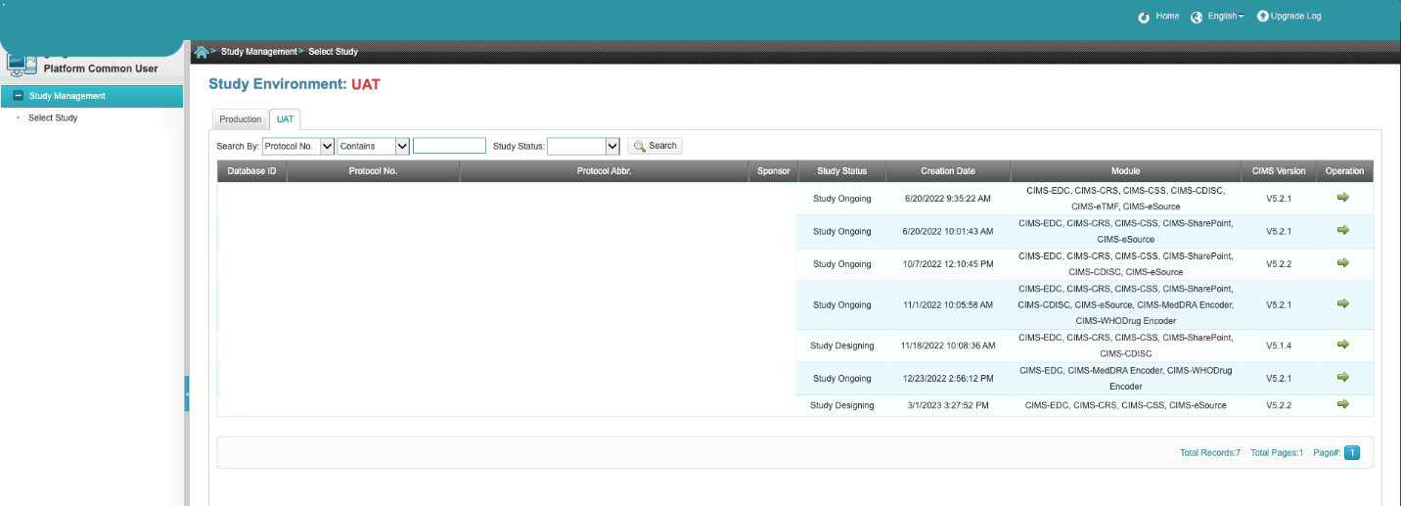

Figure 2 – Select the study

  - Click ‘OK’. The User ‘Welcome’ Main Screen will appear (Figure 3), with “My To-Do List” reminder links for easy access to unfinished tasks (Figure 3).

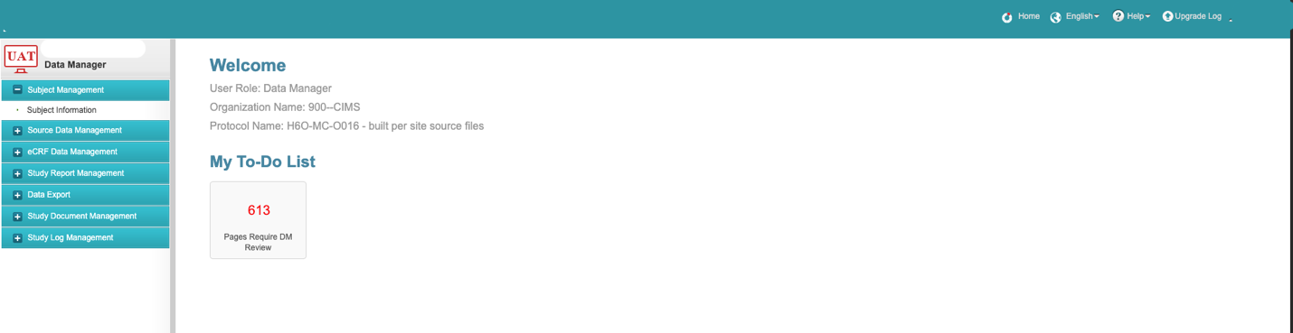

Figure 3 – The User ‘Welcome’ Main Screen

Data Mapping Template

  - To map source data form to eCRF form, proceed to the 'Source Data Management' section, click on 'File OCR' and then select the 'Mapping' button located in the top-right corner of the screen.

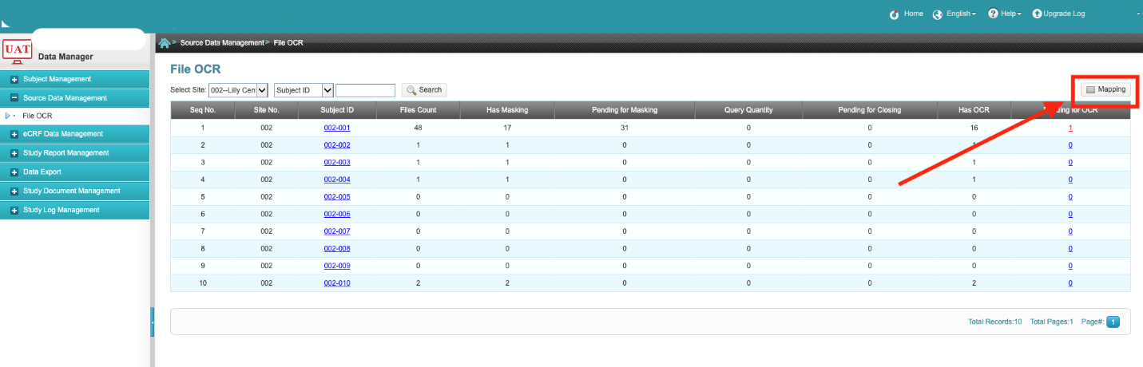

  - Choose the site from the template file dropdown list located in the top-left corner.

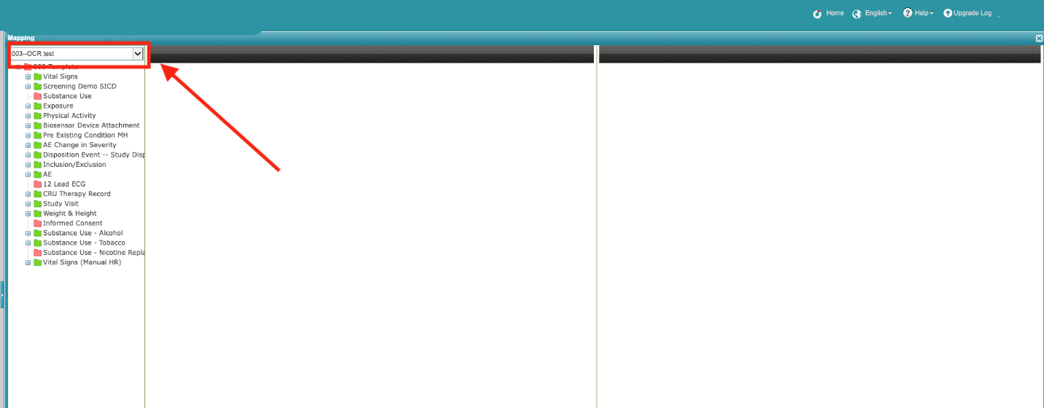

  - Select the desired form from the template file, and the origin source template file will appear on the left-hand side while the corresponding eCRF will be displayed on the right-hand side.

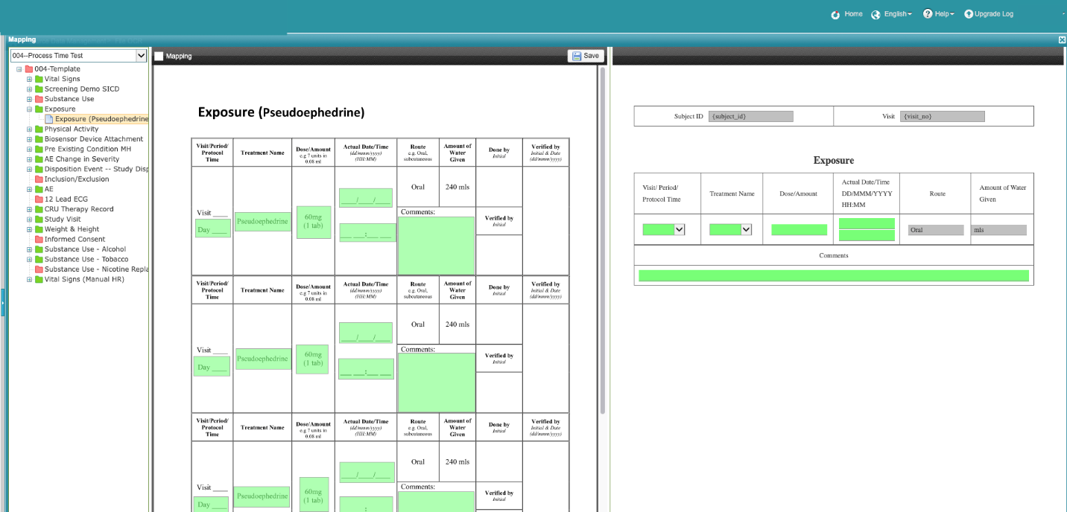

  - Select the Mapping checkbox located in the top-left corner to start mapping.

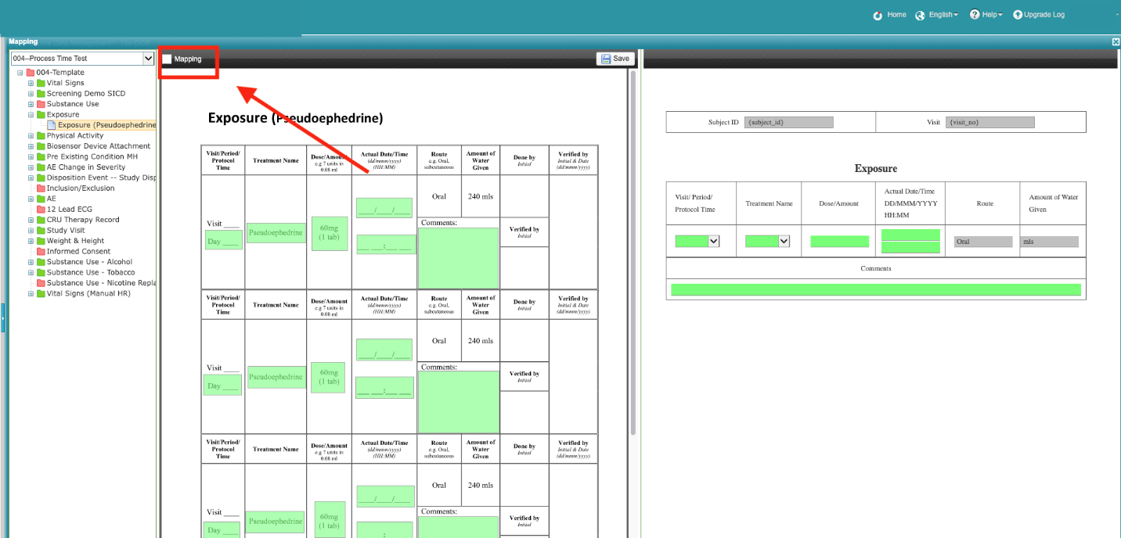

  - To select a field for mapping, left-click the mouse and draw a gray rectangle around the desired data field in the origin source template file. Adjust the rectangle to cover the entire content of the selected field.
To delete the gray rectangle, press the Delete button on the keyboard."

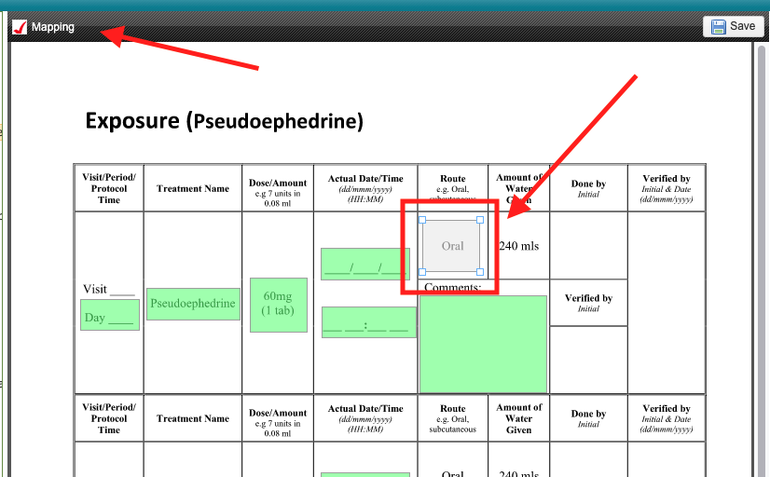

  - Double-click on the gray rectangle, then select the corresponding field on the eCRF in the dropbox and click OK. Once you have clicked OK, the gray rectangle will become a green rectangle indicating that the field has been mapped successfully.

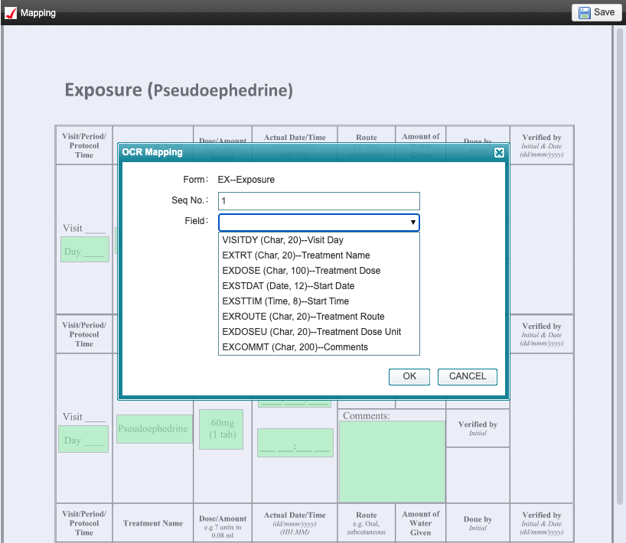

  - To save the mapping results, click on the 'Save' button located in the center of the screen

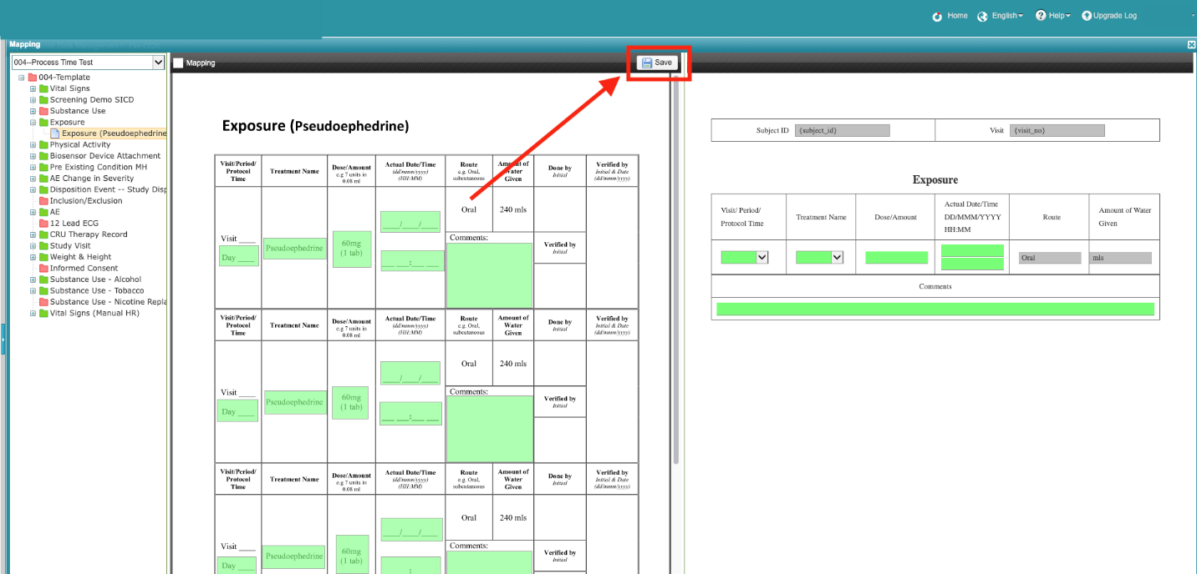

Source Data Management – File OCR

4.1. After data mapping templates are set up, the DM can start to file OCR. Click on 'File OCR' under 'Source Data Management', and then click on the selected subject to access the file list.

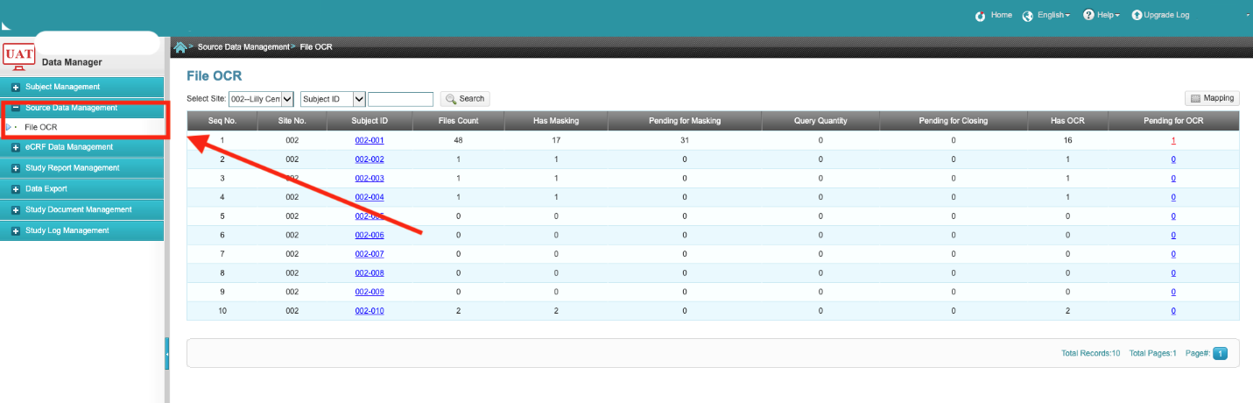

4.2 The left-hand side of the file list page displays all source data PDFs that were uploaded by the
CRC. Each file on the left has two bars on its left-hand side. The M bar indicates the file mask status, while the O bar indicates the file OCR status. A blank bar indicates that the current status has not been checked or saved yet. A yellow bar indicates that the current status has been processed but not saved yet, while a green bar indicates that the current status has been saved.

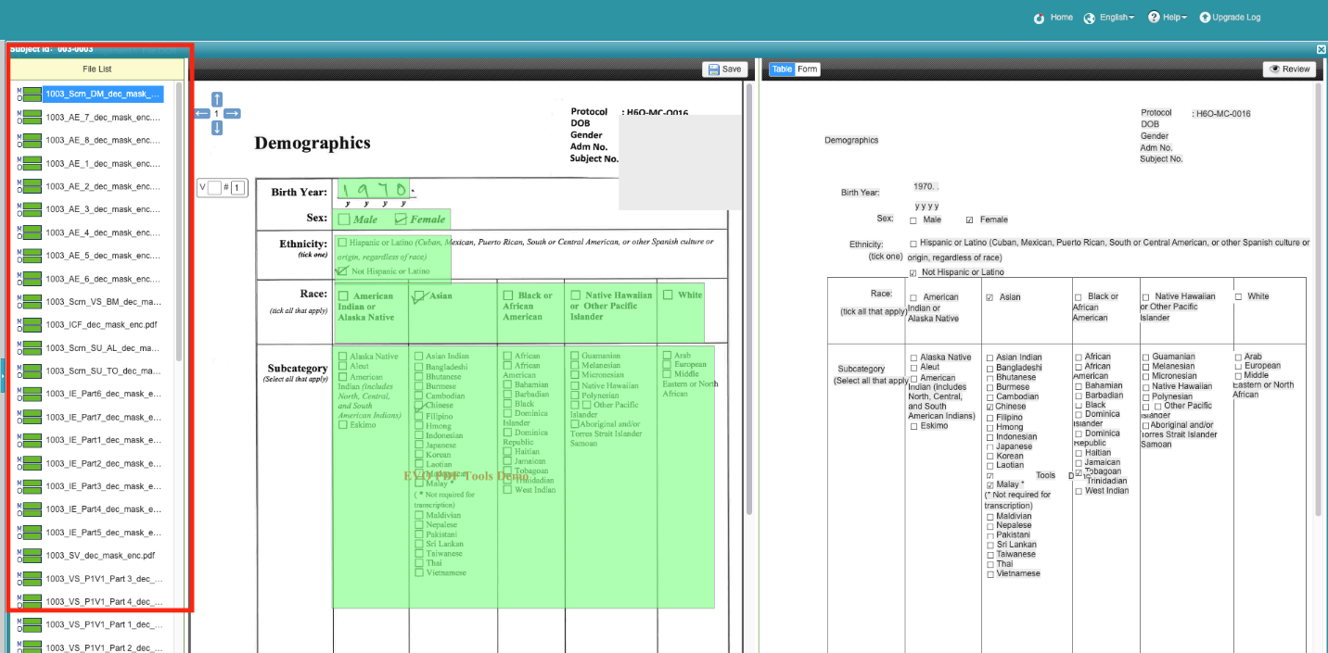
(Note: : Has been masked and reviewed : Drafted : Has a query)

  - If the actual uploaded source data file has any displacements from the preset mapping template form, you can use the green rectangle on the left to adjust the corresponding field and click “Save” to save the update.

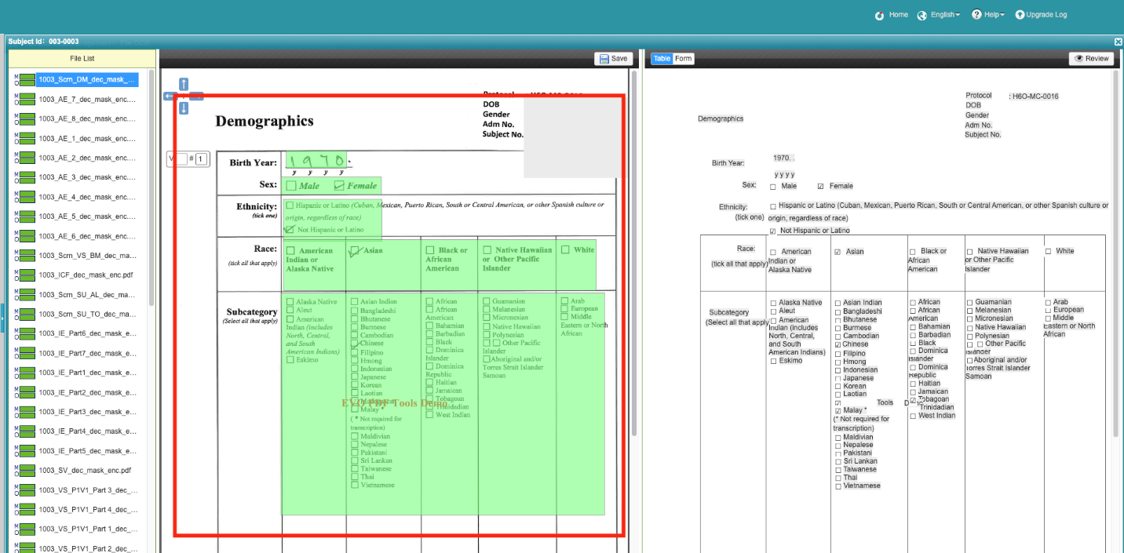

  - The system will display the corresponding OCR result table on the right-hand side. Please review the OCR result and compare it with the source file data. If the any field of the OCR result do not match the original data or have any reading error, you can manually change the data on the OCR result table.

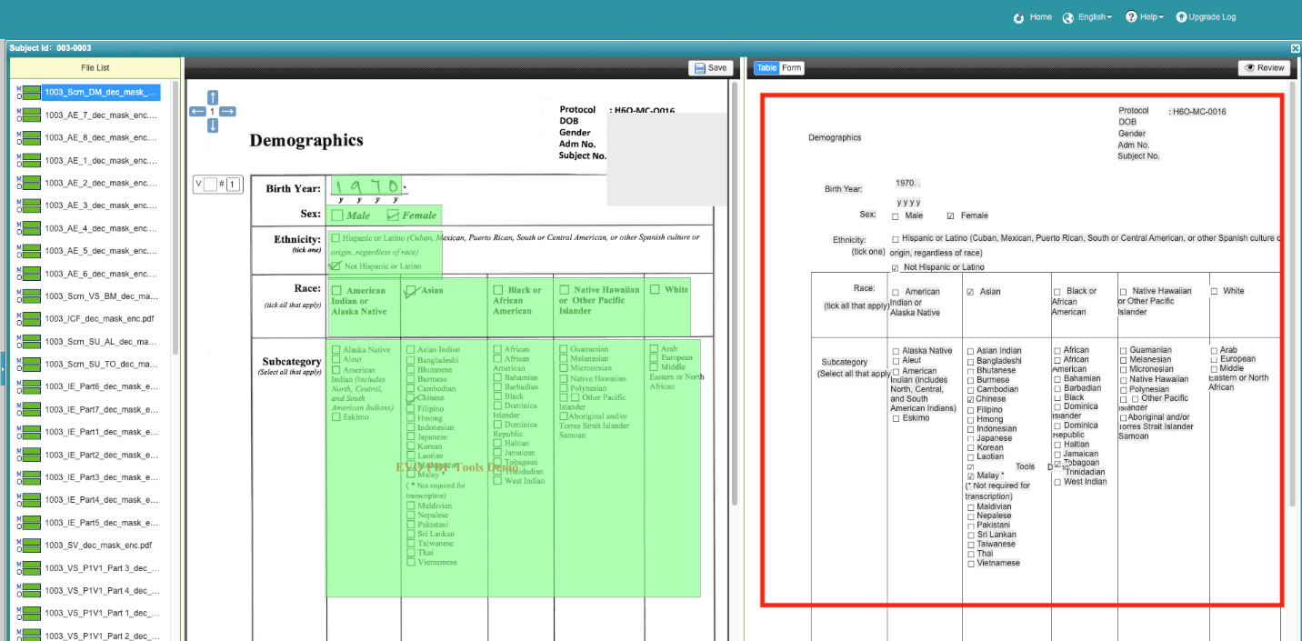

  - After comparing and verifying the OCR result, click the 'Review' button located in the upper-right corner to save the result. Once saved, the O bar corresponding to the file on the left-hand side will turn green to indicate the OCR is succesfully completed.

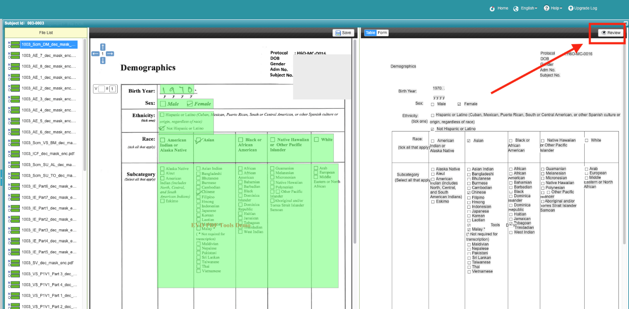

  - To switch between the OCR recognition result table and the corresponding blank eCRF for viewing on the right hand side of the screen, use the “Table/Form” button located in the middle.

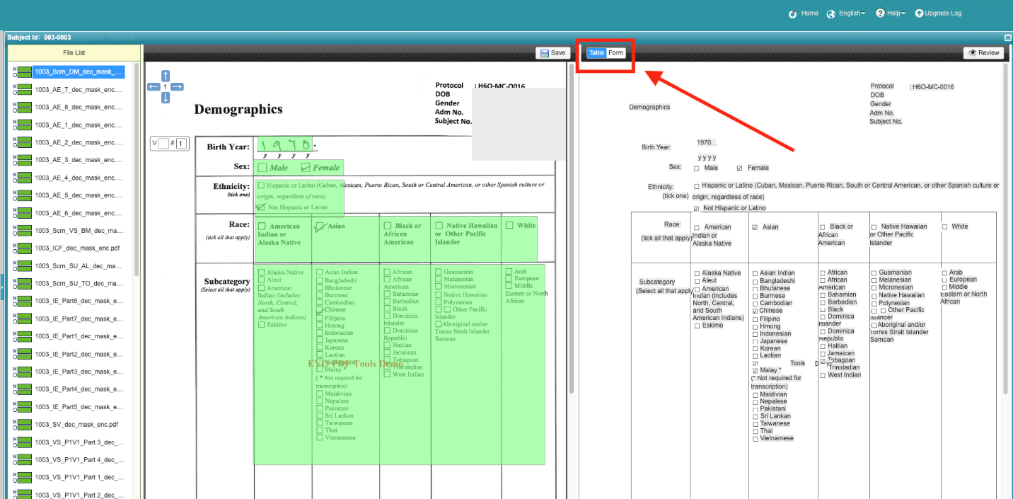

  - If there is any more questionable issues with the data on the OCR result table, move the mouse cursor over the questionable field in the OCR result and click the 'Query' button. Fill in the query description and click 'OK'. The current O bar status of the corresponding file in the left-hand side file list will then turn red.

